LTE Single Site Verification Report (202MSC-HA0070-LTE)


T

General Info & site location

Site Information
City : | Harare
Site Name : | 202MSC-HA0070-LTE
eNodeB ID | 7001
Latitude: | -17.8504
Longitude: | 31.05498
# of cells (LTE) : | 3

Site Parameter
 | Physical Cell Information
 | Activity / Process |  |  |  | Sector1 |  |  |  |  | Sector2 |  |  |  |  | Sector3
 | Azimuth |  |  |  | 0 |  |  |  |  | 120 |  |  |  |  | 240
 | Antenna height |  |  |  | 36 |  |  |  |  | 36 |  |  |  |  | 36
Test No./Name |  | Test | Activity / Process |  |  |  | Cell 1 |  |  |  | Cell 2 |  |  |  |  |  | Cell 3
 |  | Sub No. |  |  |  |  | Planned | Found |  |  | Planned |  | Found |  |  |  | Planned | Found
T02-Cell Information |  | 1 | Cell ID correctly defined |  |  |  | 7001_1 | 7001_1 |  |  | 7001_2 |  | 7001_2 |  |  |  | 7001_3 | 7001_3
 |  | 2 | TAC correctly defined |  |  |  | 1 | 1 |  |  | 1 |  | 1 |  |  |  | 1 | 1
 |  | 3 | PCI correctly defined |  |  |  | 0 | 0 |  |  | 1 |  | 1 |  |  |  | 2 | 2
 |  | 4 | MIMO correctly defined |  |  |  | 2T2R | 2T2R |  |  | 2T2R |  | 2T2R |  |  |  | 2T2R | 2T2R
 |  | 5 | Bandwidth correctly defined |  |  |  | 10MHz | 10MHz |  |  | 10MHz |  | 10MHz |  |  |  | 10MHz | 10MHz

Test No./Name | Cell | Activity / Process | OVERALL
Test No./Name | Cell | Activity / Process | Att. | Succ.
T03- Connection | 1 | PS performs successfully | 3 | 3
T03- Connection | 2 | PS performs successfully | 3 | 3
T03- Connection | 3 | PS performs successfully | 3 | 3

Test No./Name | Test | Activity / Process | Cell 1 | Cell 2 | Cell 3
Test No./Name | Sub No.
T05- Throughput | 1 | Peak DL Throughput (Mbps) | 69.840 | 70.250 | 70.130
T05- Throughput | 2 | Peak UL Throughput (Mbps) | 24.58 | 24.71 | 24.34
T05- Throughput | 3 | Latency (ms) | 20 | 22 | 18

Site Coverage Plots

RSRP
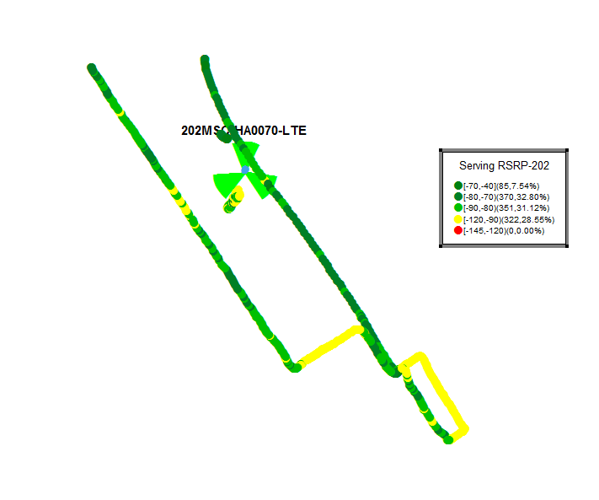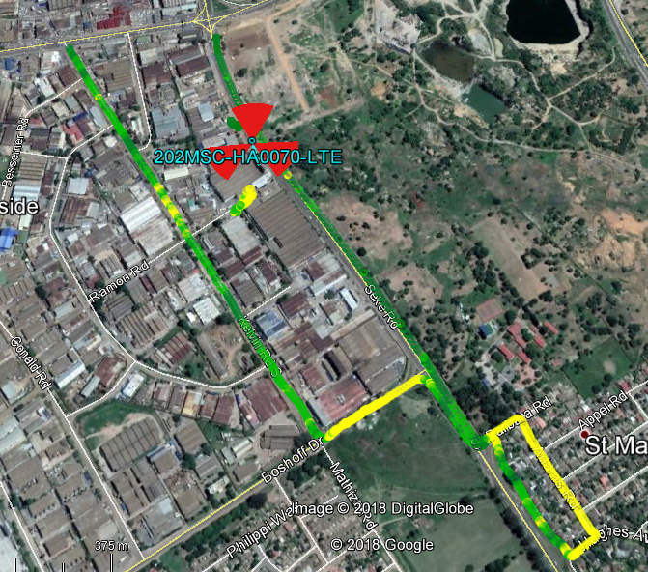
SINR:
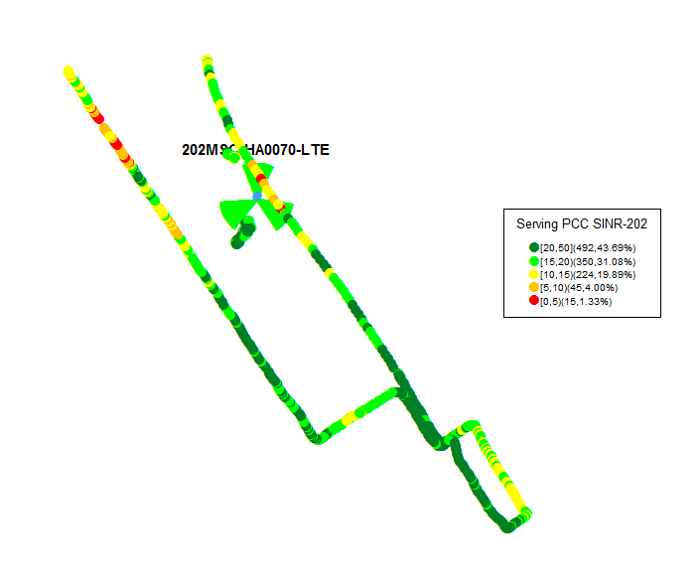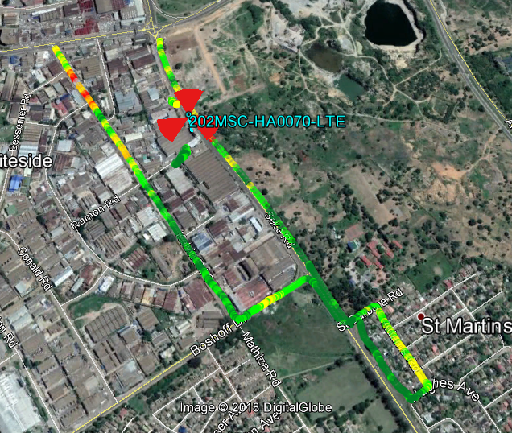

LTE PCI Plot:
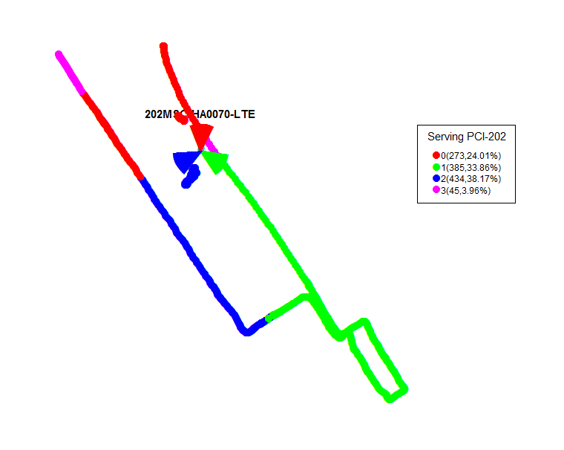

LTE Throughput Plot
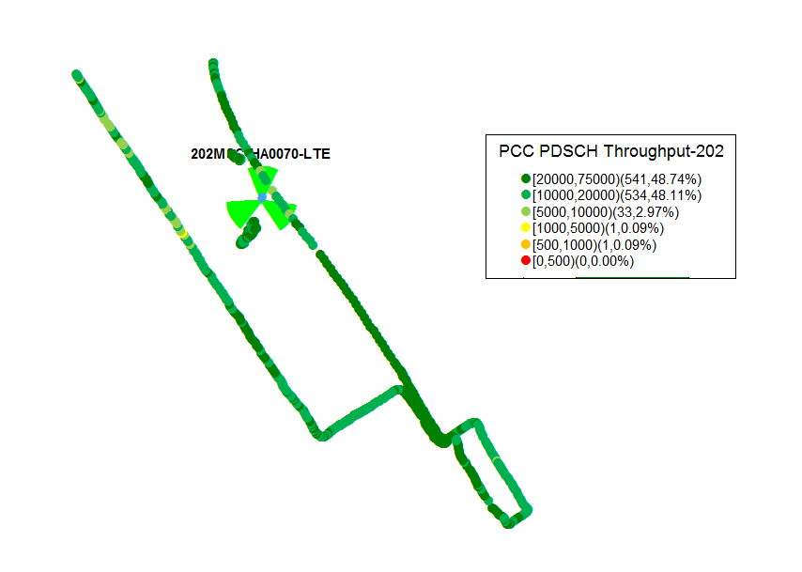

LTE Test Graphs
LTE Throughput Graphs
Sector 1
- LTE PHY Throughput PDSCH:
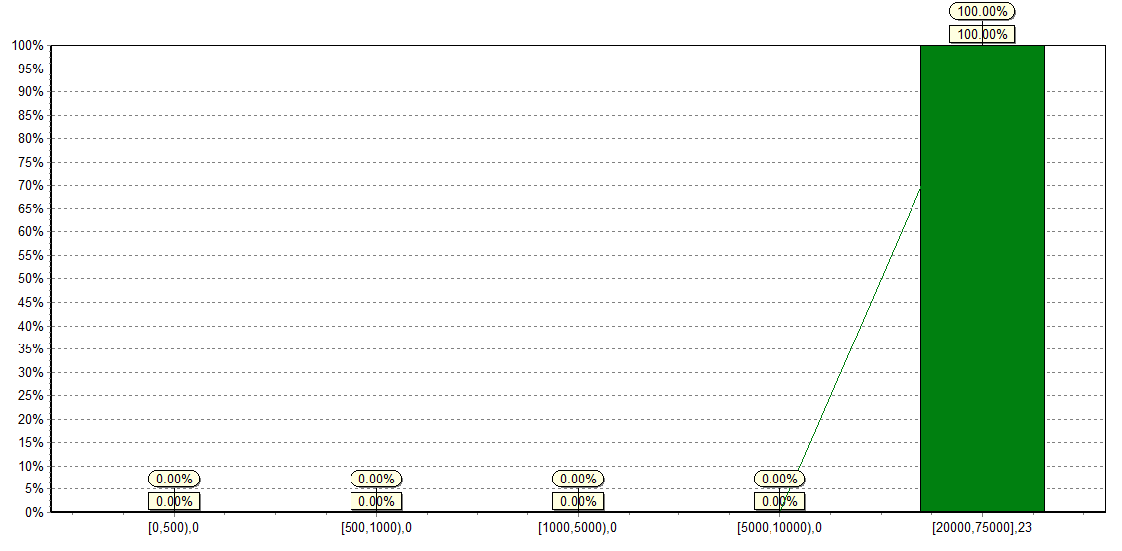
ii) LTE PHY Throughput PUSCH:
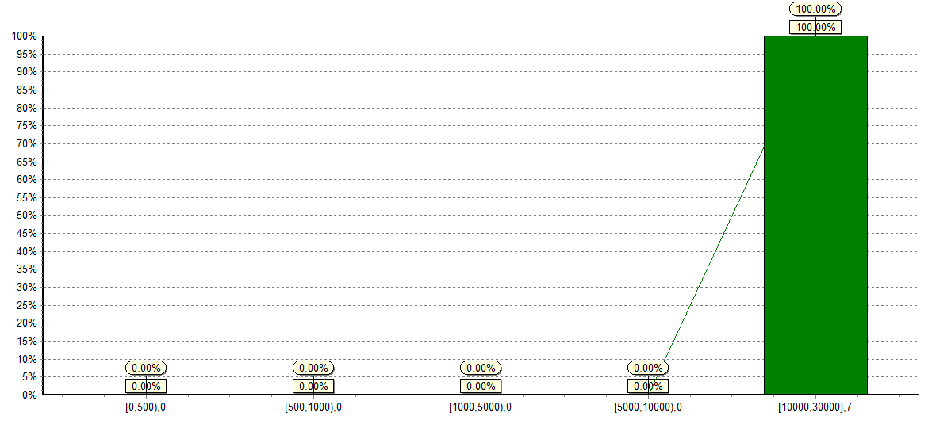

Sector 2
i) LTE PHY Throughput PDSCH:
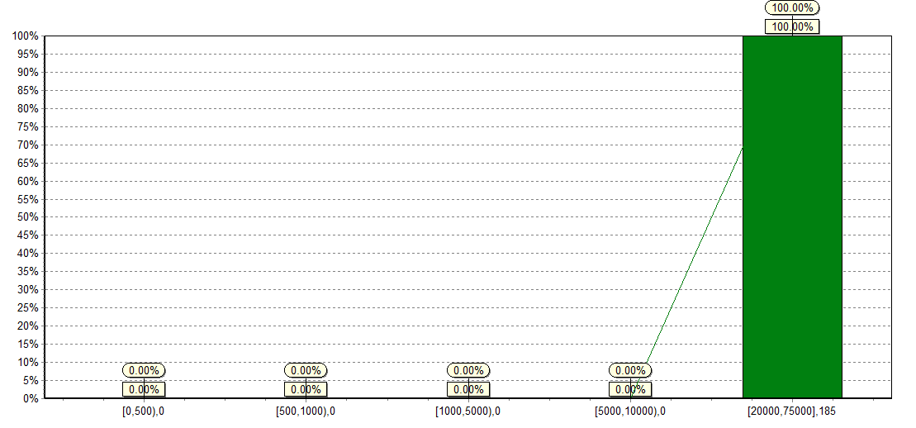
ii) LTE PHY Throughput PUSCH:
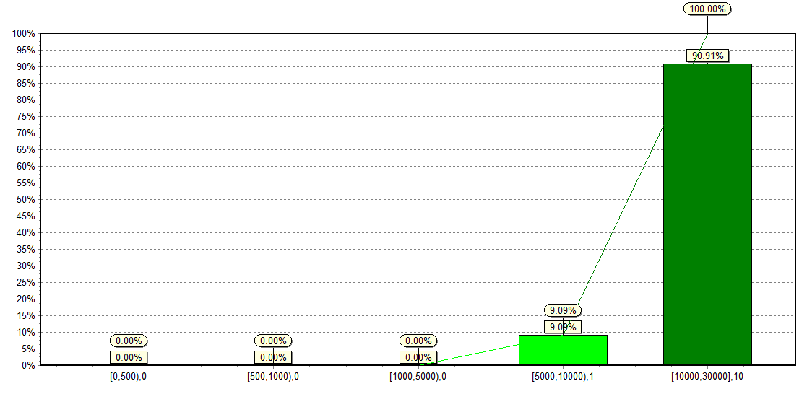

Sector 3
i) LTE PHY Throughput PDSCH:
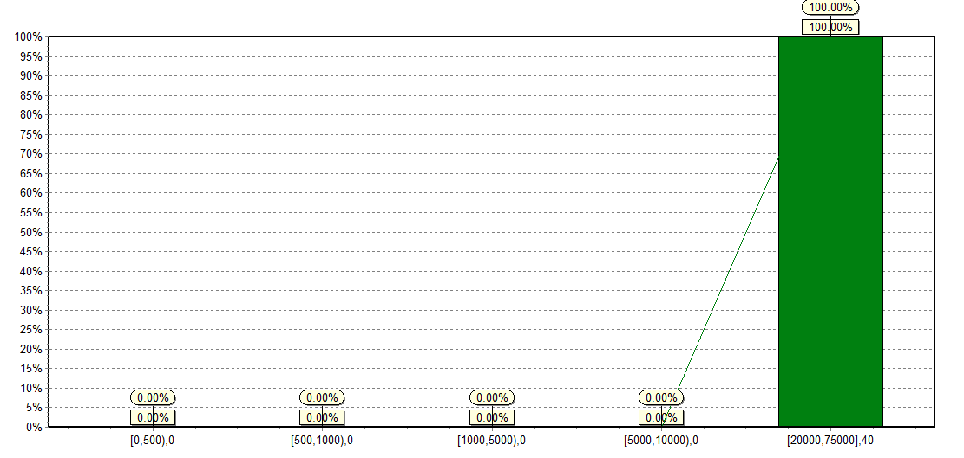

ii) LTE PHY Throughput PUSCH:
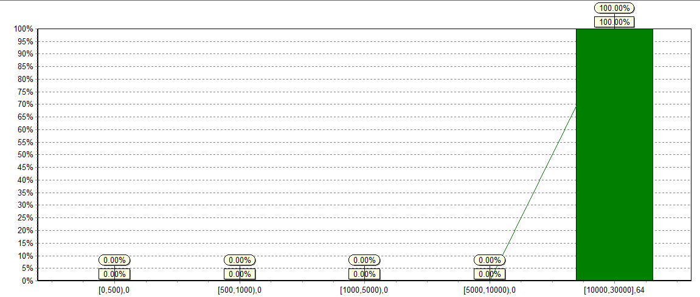

Signature

Huawei | Sign
Huawei | Date
TELECEL | Sign
TELECEL | Date

